Sample Enterprise Architecture for a Retail & eComm Store with Azure Cloud Services.
(Disclaimer: I’m not a domain expert on the topic. The only purpose of this document is to entice discussion about microservices architecture and Azure Cloud services.)

A mid-sized retail stores chain wants to migrate their IT legacy infrastructure to the Azure cloud services. They have presence on the east and west coasts of the US. They also have an Online Store and occasionally sell hot-topic products. They have their own freight fleet, so online orders can use inventory from all warehouses.

Of upmost importance is data security and high availability. It is also important that the retail checkout flow is quick.

They want to continue using their legacy data warehouse for the time being and gradually migrate to the Azure analytics services.

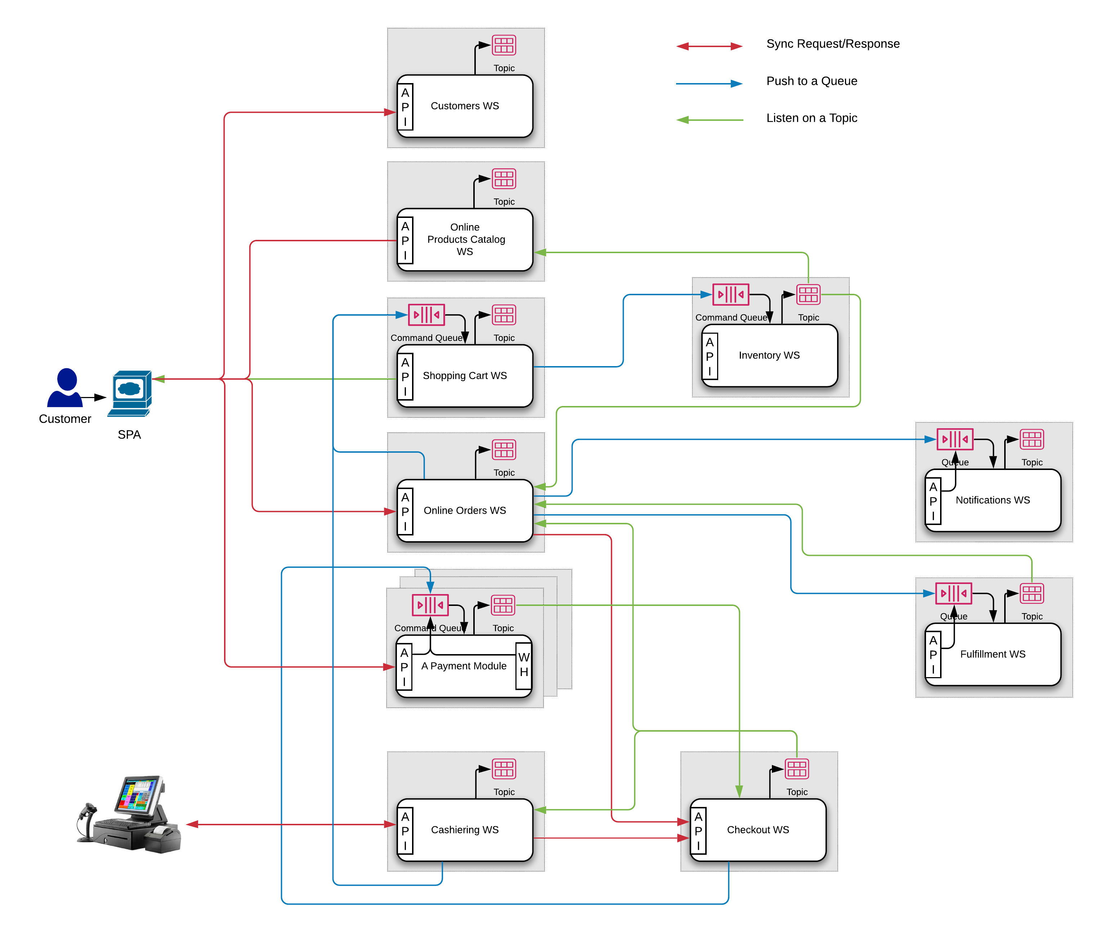

Domain Services:
We will build our services according to the Twelve-Factor App methodology. The services will be designed to be lightweight, ephemeral, and stateless. Service interaction will be asynchronous and event driven for reduced coupling and easy integration with downstream consumers.
All APIs are protected and require a valid Access Token from a trusted IdP. All topics and queues are accessible only by authenticated and authorized services.

- Customers WS – The service that stores Customers’ details and credentials.
  - API: Synchronous RESTful
    - Public endpoints. Where “create new customer” is not protected endpoint.
  - Storage: NoSQL. Aggregates: Customer. Mainly inserts and reads.
  - Events:
    - Publishes on its own Topic upon Customer state change.
    - Publishes on its own Topic upon credentials check.

- Online Products Catalog WS - The Online Products and Promos storage.
  - API:
    - Public RESTful endpoints. Provides a view of the catalog to customers.
    - Public Websocket for: Live product availability updates; Activity logging (Every customer's interaction with the products UI is logged (e.g. mouse clicks)).
    - Restricted RESTful endpoints. Provides CRUD operations over the Products Catalog to Admins.
  - Storage: NoSQL. Aggregates: Product, Promo. Mainly reads.
  - Events:
    - Publishes on its own Topic every customer's interaction with the products UI.
    - Listens on the Inventory Service Topic for changes with items availability.

- Shopping Cart WS - A service used by both Online Orders WS and Cashiering WS. (There might be two clustered instances for each one.)
  - API: CQRS/ES – Will handle graciously spikes in activity.
    - Public RESTful (eventually consistent) View of current user's Shopping Cart (content).
    - Public “Server-Sent Events” endpoint for one-way messaging upon Shopping Cart changes.
  - Storage: NoSQL. Aggregates: Shopping Cart View.
  - Events:
    - Listens on the Command Queue for added/removed items or changes of status, then updates the view model and triggers other events.
    - Publishes on its own Topic upon Shopping Cart state change.
    - Pushes on the Inventory Service Command Queue for each item added to or removed from the Cart.
    - Pushes on the Inventory Service Command Queue for each item from the Cart upon Cart status change. (E.g. paid or abandoned)

- Online Orders WS - Creates and updates the Shopping Cart. Calculates and applies discounts. Initiates checkout flow. Acts on events from the Inventory WS, Checkout WS, and Fulfillment WS. Sends notifications.
  - API: Synchronous RESTful
    - Public endpoints.
  - Storage: NoSQL. Aggregates: Online Order.
  - Events:
    - Publishes on its own Topic upon Online Order state change.
    - Listens on the Inventory Service Topic for errors due to negative availability and (for example) sets the status of the latest Order to "check inventory". A compensating action.
    - Listens on the Checkout WS Topic for own Payment Session status changes.
    - Pushes on the Notifications Service Ingress Queue upon Online Order status change.
    - Pushes on the Fulfillment WS Ingress Queue when an Order is ready to be shipped.
    - Listens on the Fulfillment WS Topic for updates.

- Cashiering WS - A backend proxy for the Cashier Station Application. Tracks Cashier Session. Creates and updates the Shopping Cart. Applies discounts. Initiates checkout flow. Acts on events from the Checkout WS.
  - API: Synchronous gRPC or RESTful
    - Restricted endpoints. Only Cashiering Stations have access to it.
  - Storage: NoSQL. Aggregates: Cashier Session.
  - Events:
    - Publishes on its own Topic upon Cashier Session state change.
    - Listens on the Checkout WS Topic for Payment Session status changes.

- Checkout WS - Links a Shopping Cart to a Payment Session with potentially multiple payments under it. It also serves as a payment flow broker to various Payment Modules or third-party payment service.
  - API:
    - Synchronous private endpoints (gRPC or RESTful) accessible only via back-end channels for initializing a payment session. Online Orders and Cashiering WSs initialize a payment session via it.
    - Protected webhooks for PMs and third-party services to push events. External events are immediately pushed into a queue.
  - Storage: NoSQL. Aggregates: Standard Payment Session.
  - Events:
    - Listens on the events queue and updates Standard Payment Session status accordingly.
    - Publishes on its own Topic upon Standard Payment Session state change.

- Payment Module(s) WS - A Payment Module handles a distinct payment type. Facilitates the completion of the payment flow. Provides e-wallet functionality.
  - API: CQRS/ES - Payment state changes are event driven and asynchronous. Events could be triggered by various external or internal agents.
    - Public and Private Adapters (endpoints and webhooks)
    - Public endpoints for Payment Session view.
    - Public “Server-Sent Events” endpoint for one-way messaging upon Payment Session changes.
  - Storage: RDBMS. Data structure is strict and relational. Payment transactions requires strong consistency. Security considerations. Transaction might span across aggregates.

- Inventory WS - Inventory management system. Used by eComm for availability checks on global scale.
  - API: CQRS/ES - Must handle a huge number of concurrent commands (e.g. “Reduce inventory of product A”). Eventually consistent Inventory view is acceptable.
    - Restricted RESTful (eventually consistent) View of inventory state.
    - Restricted RESTful Adapter for the Command Queue for changes in inventory state.
  - Storage: RDBMS or NoSQL. Data structure is strict. A single aggregate property is updated frequently. Transaction is bound to an aggregate (likely).
  - Events:
    - Listens on the Command Queue, processes commands and updates state view.
    - Publishes on its own Topic upon item availability change.
    - Publishes on its own Topic upon negative availability error so dependent services can apply a correcting action.

- Notifications WS - Sends notification messages based on templates via various channels.
  - API: Asynchronous RESTful.
    - Private async endpoint for accepting notification requests
    - Public endpoints for fetching notification(s) status and etc.
  - Storage: NoSQL. Aggregates: Template and Notification.
  - Events:
    - Listens on the ingress queue and processes notifications.
    - Publishes on its own Topic when notification is processed.

- Fulfillment WS - Handles everything around the logistics for shipping and handling.
  - API: Asynchronous RESTful.
    - Private async endpoint for accepting fulfillment requests.
    - Restricted endpoints for authenticated and authorized employees.
  - Events:
    - Listens on the ingress queue, updates the state and schedules the fulfillment.
    - Publishes on its own Topic upon Online Order Fulfillment status change.

Infrastructure:
PaaS vs IaaS is a big topic, but when a PaaS solution meets our functional, throughput, scalability, SLA requirements and the estimated cost is less than an initial IaaS cost, the decision is easier. When we are choosing PaaS solutions we should be careful and make sure a later switch to IaaS (or another cloud provider or even on-prem) is possible.

Multi-Region and Geo-Redundant Deployment - To reduce latency and implement high availability we should deploy the essential services in at least 2 geographic regions (e.g. East and West coast). For global load balancing we could go with Azure Front Door for its path-based routing, fast failover, IP based ACL and general WAF abilities.

Web Services - We could deploy our containerized services on VM Nodes and orchestrate them with Azure Kubernetes Service (AKS). We could implement Service Mesh by installing Istio Control Plane and adding an Istio sidecar proxy to all of our pods. We could start with a few nodes (in each region) in an Availability Set in a single Availability Zone (HA & DR are covered by the multi-region deployment). We should select VM of type that supports ephemeral OS managed disks to increase logging throughput. Service logs are shipped as quickly as possible to Azure Blob Storage or Azure Data Lake Storage for ingestion by ELK stack or other logs aggregation/analytics services.

Network - We should create a Virtual Network per region and have at least two subnets per VN - one for the public services and one for the private services and storage. We could use Application Security Groups and Network Security Groups to manage network access control. We have to setup Azure Private Link to enable assignment of subnet IPs to PaaS offerings that we use. We should peer the two virtual networks to allow data replication.

Authentication - An OAuth2/OIDC IdP implementing Authorization Code with PKCE Flow.
Employees - For employees’ authentication we could use Azure Active Directory. We will structure different types of employee accounts under a management groups hierarchy. Although there is no equivalence on other cloud platforms, AAD offers easy integration with on-prem Windows Server AD and SSO. Due to the ubiquity of AD across enterprises this is a good option.
Customers - We could use Azure AD B2C policies. B2C policies provide flexible authentication journeys. We will set up a policy that uses the Customers WS for credentials check or federates with other IdPs (e.g. social networks).

Queues and Topics - We could go with Azure Event Hubs. Event Hubs is similar to Kafka and it supports AMQP and the Kafka protocol as well. Event Hubs offers enterprise level performance, security, high availability and reliability. It integrates easily with other Azure Services (e.g. Stream Analytics). There is a constraint we have to consider - events and commands must be smaller than 256KB in size.
Event Hubs are transient storage. We want to preserve the events causing state changes. To do this, each service (CQRS, eRPC or RESTful) will publish such events on their topic. Then we can set up Event Hubs Capture to export events in Azure Blob Storage or Azure Data Lake Storage for later processing, analytics or archiving. By creating this constraint, we relieve developers of making a decision about data changes tracking.

NoSQL Storage - Azure Cosmos DB is Microsoft's globally distributed, multi-model database service. Cosmos DB provides comprehensive SLAs for throughput, latency, availability, and consistency guarantees. Provides turnkey global distribution. Provides elastic scalability of throughput and storage. Supports different consistency models (session default). Cosmos DB offers a variety of APIs. By default, you can use SQL (a core API). Cosmos DB also implements APIs for Cassandra, MongoDB and Azure Table Storage.
When the model allows it(!), geo-distributed data is requirement and a good candidate for partitioning key exists, Cosmos DB should be considered the main contender for a DB storage since the overall cost/performance effectiveness is much greater than an Azure SQL PaaS/IaaS.

RDBMS Storage - Azure SQL Database Hyperscale is a strong candidate if all of our services requiring RDBMS are deployed in one region since it does not support geo-replication.
To select the most optimal SQL Server service tier and purchasing model, one must understand the domain in a great dept. What are the scaling requirements for storage, IO, CPU? The shape of the load (constant or spiky)? Geo-replication? Downtime tolerance? Data partitioning (vertical and horizontal)? Cost vs performance tolerance? Required functionality (Some offerings have a limited functionality) ...

Caching - A rather important infrastructure piece in the cloud space. Besides improving application performance, it helps with storage related costs. A good candidate is Azure Redis Cache.

Tasks - With event driven distributed applications is to be expected that some inconsistencies will occur. It is a good practice to implement tasks such as Archiving, Reconciliation and Consistency Check. Those could be scheduled to run off-hours or all the time. The obvious PaaS solution is Azure Batch, but this could be implemented with a custom/other task schedulers/launchers nonetheless. One benefit of Azure Batch is that allows the use of low-priority VMs. Such tasks could also help with storage related costs.

Analytics - We have the following data streams ready to be analyzed
- Azure cloud infrastructure and services logs.
- Our Apps and Services logs.
- Services publishing state changing events on their Event Hub (Topic).

We could use Azure Monitor for monitoring the health and performance of our cloud infrastructure and applications. We can fetch our app logs under it for querying and analysis. We can create alerts and automated actions (e.g. auto scale) as well as visual reports and dashboards. Azure Monitor is a very powerful tool, but an ELK stack solution could be used as well. Logs could be also analyzed and transformed using Data Lake Analytics jobs.

For general BI practices we could use a classic Data Warehouse populated by ETL processes and classic OLAP services. In our case we have to maintain the on-prem data warehouse for the time being. We can use Azure Data Factory to export data from our cloud data stores, transform it, and load it into our on-prem data warehouse. When the BI team is ready to migrate to the Azure's platform the on-prem DW and OLAP could be migrated to Azure Synapse Analytics (DW) and Azure Analysis Services (OLAP) respectively.

For real-time auditing and live business stats we could use Azure Stream Analytics. Once integrated with our Event Hubs, we could use Azure Machine Learning to detect fraudulent orders in close to real time. We could also integrate with Power BI for visual representation of the live business stats.

Ci/CD – There are many options but Azure Pipelines should be considered first as they readily integrate with Azure services and Microsoft products.

